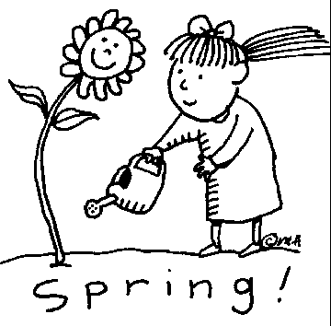 SPRING 2018 NEWSLETTER
Welcome to this issue of our Practice Newsletter. The newsletter is to provide patients with any news, information or forthcoming events. If you have any suggestions as to what you would like to see in your newsletter please inform a member of staff

Bank Holiday Dates
Please make a note of the dates below of our opening times over the Easter and May bank holidays. If you need a doctor in an emergency please telephone NHS 111.
- Friday 30th March Closed Good Friday
- Saturday 31st March Closed
- Sunday 1st April Closed
- Monday 2nd April Closed Easter Monday
- Tuesday 3rd April Open as normal
- Monday 7th May Closed May Day
- Monday 28th May Closed Spring Bank Holiday

Repeat Prescriptions
Please ensure you only order the medication that you need rather than ticking everything on your repeat slip. Please allow 48 hours for collection and ensure you have enough medication to last over the holiday periods.

Practice Participation Group
We have now opened a face book page for our patient participation group please search Eccleshill Village Surgery when logged into your account, alternatively you can ask at reception and the admin team can add you to the page.

Travel Advice
Our Practice Nurse is able to give pre travel advice before you go abroad , please contact the surgery at least 6 weeks before travelling .

Our summer newsletter will be printed June 2018 .

